1. For the circuit below find the equivalent resistance between the terminals of a and b.

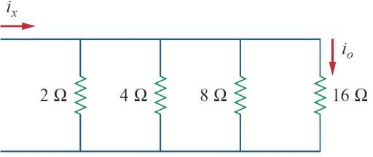

a b

Answer 1:

Reg = $\frac{1}{\frac{1}{R_{1}}+\frac{1}{R_{2}}+\frac{1}{R_{3}}+\frac{1}{R_{4}}}$

Reg = $\frac{1}{\frac{1}{2}+\frac{1}{4}+\frac{1}{8}+\frac{1}{16}}$ = Reg = $\frac{1}{\frac{15}{16}}$ = $\frac{16}{15}$

1. İf İx=15 A, calculate I0.

Answer:

I =V.()

IX =V.()

15=

15.16 =

V=16

I1 = = = 8A

I2 = = = 4A

I3 = = = 2A

I4 = = = 1A

I0 = 1A